Найти экстремум функции F(X) четырьмя методами (методом золотого сечения, методом ломаных, методом касательных, методом Ньютона).
№ | F(X) = | Тип экстремума | Исходный интервал | Погрешность
1 | 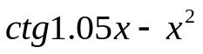 | max | [4; 9] | 0.02
2 | 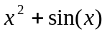 | min | [-1; 0] | 0.005
3 | 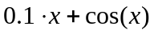 | max | [4; 9] | 0.02
4 | 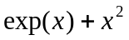 | min | [-1; 0] | 0.005
5 | 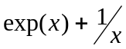 | min | [0.5; 1] | 0.001
6 | 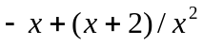 | min | [-2; 0] | 0.01
7 | 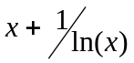 | min | [-1.5; 3] | 0.01
8 | 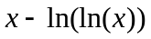 | min | [1.3; 3.0] | 0.01
9 | 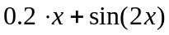 | max | [0; 3] | 0.02
10 | 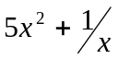 | min | [0; 2.5] | 0.02
11 | 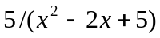 | max | [0.8; 2.0] | 0.008
12 | 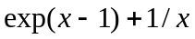 | min | [0; 1.5] | 0.01
13 | 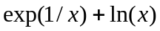 | min | [1; 3] | 0.012
14 | 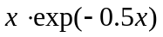 | max | [0; 3] | 0.02
15 | 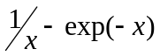 | max | [-1; 0.5] | 0.005
16 | 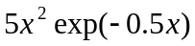 | max | [2; 6] | 0.02
17 | 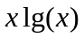 | min | [0; 2] | 0.01
18 | 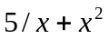 | min | [0.5; 2] | 0.01
19 | 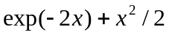 | min | [0; 1.5] | 0.01
20 | 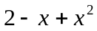 | min | [0; 2] | 0.01
21 |  | min | [0.5; 1] | 0.001
22 | 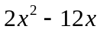 | min | [0; 2] | 0.01
23 | 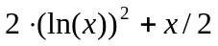 | min | [0.5; 2] | 0.005
24 | 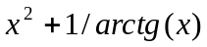 | min | [0; 2] | 0.005
25 |  | min | [-1; 0] | 0.005
26 |  | min | [1; 3] | 0.012

